ASSIGNMENT 2
Omprakash G19 ES&IOT
Control the brightness of LED without using analogWrite

Schematic
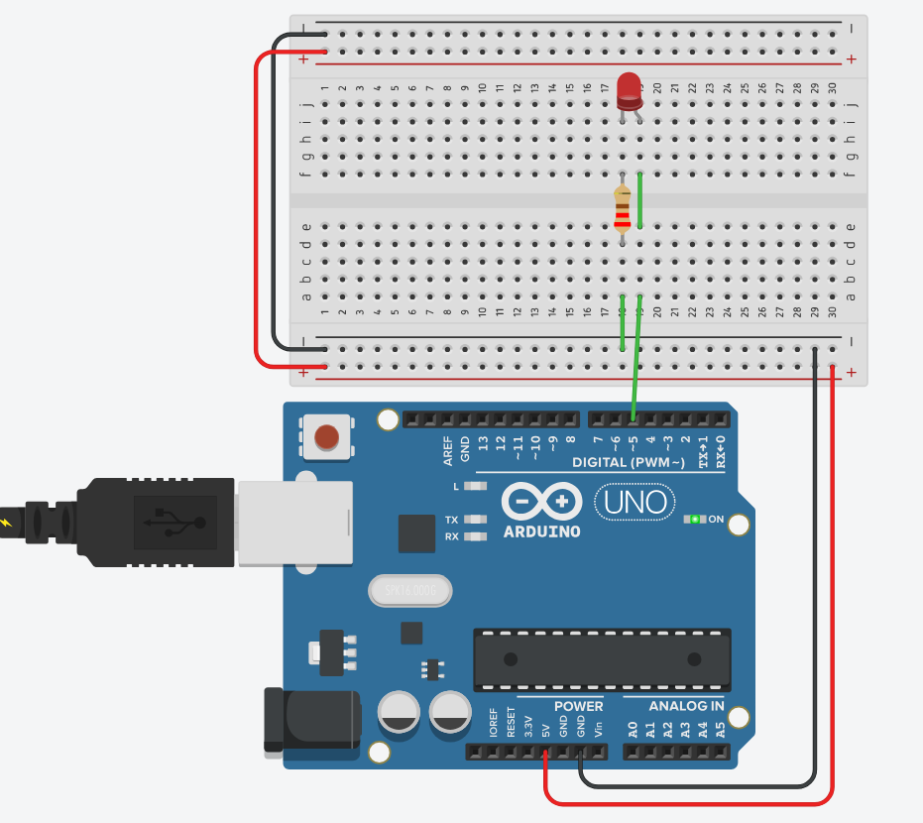
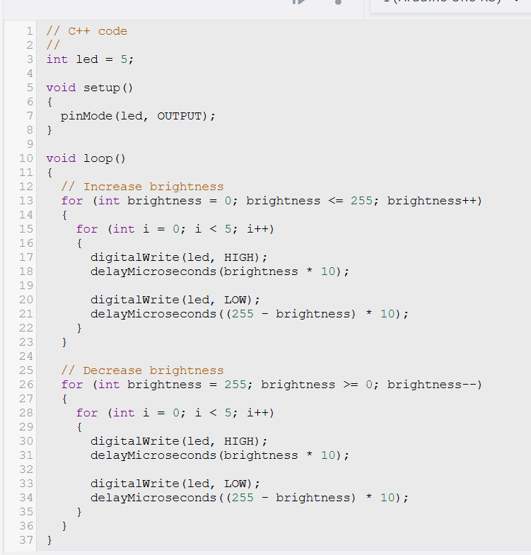
CODE

